Technical Report on How to load an App on the BlackBerry Playbook
Introduction:
The Blackberry Playbook is a very secure device, and so getting applications on to the device is a very complex process. This ensures the security of the device, but also may scare away potential developers. This report aims to clarify the process for new developers.

Equipment:
- Command Prompt Enabled Computer
  - If restrictions exist on a computer disabling command prompt, then use a different computer.
  - Computer should also have a Universal Serial Bus(USB) port
- BlackBerry PlayBook
- Micro USB to USB Cable
  - This comes with the BlackBerry Playbook. It was packaged in the same location as the power cable; underneath the plastic containing the Playbook.
Software:
- Adobe Air SDK
  - This is a required program for the BlackBerry WebWorks SDK
  - Download link: http://www.adobe.com/devnet/air/air-sdk-download.html
- Black Berry WebWorks SDK for Playbook OS
  - Version: 2.2.0.5 for windows
  - This guide utilizes this version of the software. If a different version is used the process may be different.
  - Download Link: http://developer.blackberry.com/playbook/html5/download/
- Google Chrome
  - Requirement for use of the Ripple Emulator, which is an extension of Google Chrome
  - Download Link: https://www.google.com/intl/en_ca/chrome/browser/?&brand=CHMA&utm_campaign=en&utm_source=en-ha-ca-bk&utm_medium=ha
- Ripple Emulator
  - Version: 0.9.17 beta
  - This guide utilizes this version of the software. If a different version is used the process may be different.
  - Download Link: http://developer.blackberry.com/playbook/html5/download/
  - The Ripple Emulator is not necessary; however, it simplifies the process by giving a Graphic User Interface (GUI) for a process which would otherwise be done on the command prompt

Section A: Setting up tools
This section can be skipped if both Ripple and BlackBerry WebWorks SDK are installed.

- Download Chrome if it is not already installed on the computer. If there is no web browser on the computer, download chrome directly by following the instructions outlined on this webpage: http://www.mattsilverman.com/2013/02/download-google-chrome-without-a-web-browser-using-windows-command-line.html
- Open Chrome and type in the Universal Resource Locator(URL) http://developer.blackberry.com/playbook/html5/download/
- Download the Ripple Emulator by clicking the large blue button labeled “Ripple Emulator”. 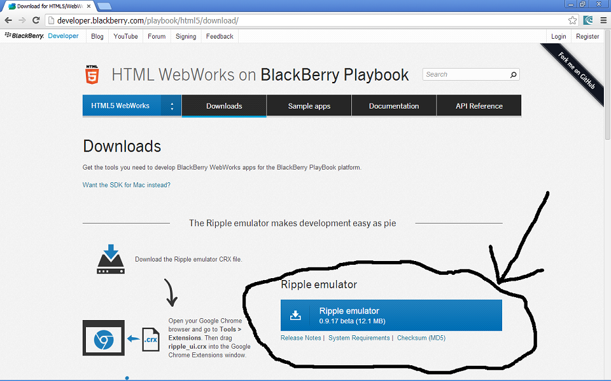
- Navigate to “My Computer\Documents and Settings\User\Downloads” on Windows XP. “User” should be replaced by the name of the computer’s user. (Note: On other operating systems navigate to the equivalent folder) And Locate “ripple_ui.crx”. Keep the folder open for the next 2 steps. 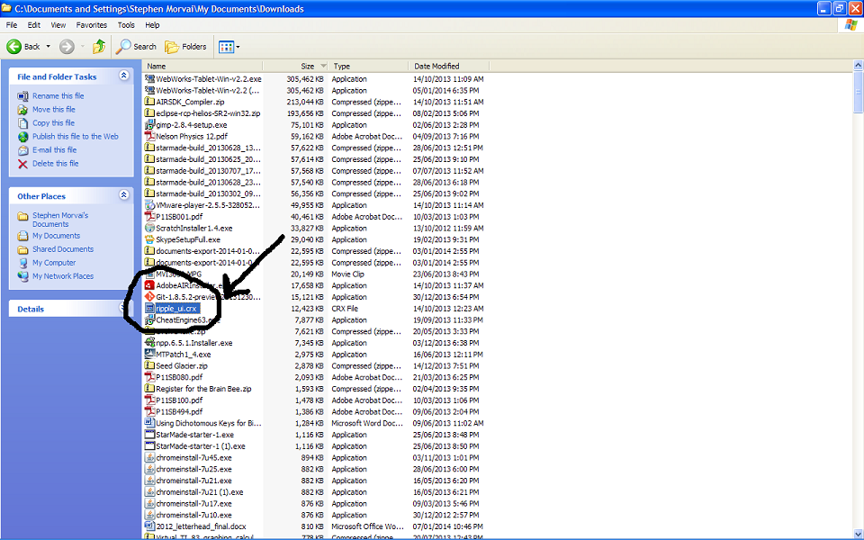
- Near the top left corner of the screen, underneath the “x” button, there should be a button with 3 parallel bars. Click on this button. It should open a drop down menu. Look for a “tools” submenu and hover the mouse over it until another menu appears. Go over to this new menu and Click “Extensions”. 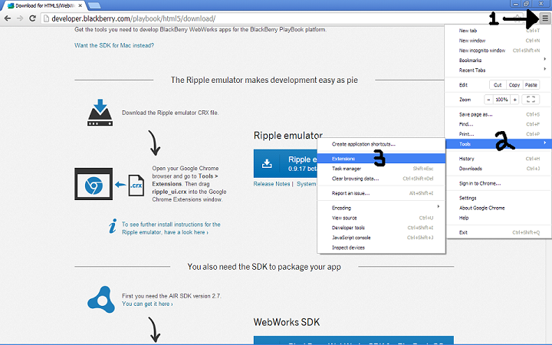
- Single Click on “ripple_ui.crx” and drag into the Google Chrome Tab Entitled “chrome://extensions”. When prompted select ADD. For trouble shooting see the instructions on this website: http://developer.blackberry.com/playbook/html5/documentation/getting_started_with_ripple_1866966_11.html#bpa1343230871668
- If the Ripple Emulator is not enabled, click the checkbox to enable it. There should be a blue button near the top right corner of Google Chrome. If not repeat step 6 and look at the link provided to see what went wrong.
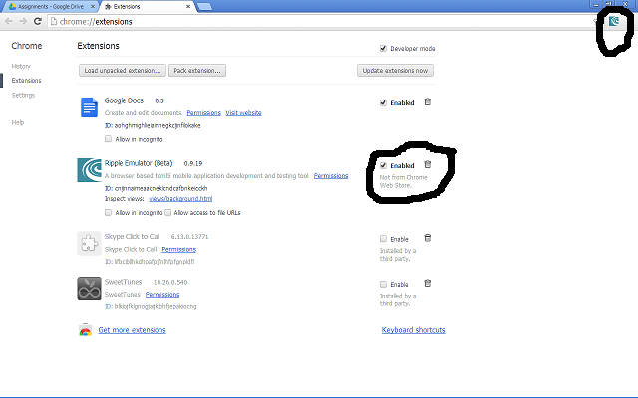
- Go to the URL http://developer.blackberry.com/playbook/html5/download/ and scroll down until the large blue button which says “BlackBerry WebWorks SDK for PlayBook OS” is visible. It should be the second large blue button from the top. Click it to download the software development kit.
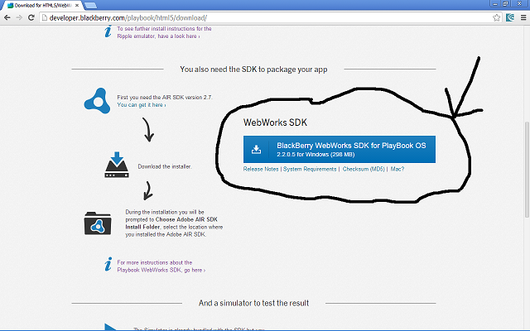
- Go to URL http://www.adobe.com/devnet/air/air-sdk-download.html and download the Adobe AIR SDK and complier for windows.
- Navigate to “My Computer\Documents and Settings\User\Downloads” on Windows XP. “User” should be replaced by the name of the computer’s user. (Note: On other operating systems navigate to the equivalent folder) And Locate “AdobeAIRInstaller.exe”. Double Click the file.
- Follow instructions outlined by the installer. Install AbodeAIR to the default location.
- Navigate to “My Computer\Documents and Settings\User\Downloads” on Windows XP. “User” should be replaced by the name of the computer’s user. (Note: On other operating systems navigate to the equivalent folder) And Locate “WebWorks-Tablet-Win-v2.2.exe”. Double Click the file.
- Follow the instructions outlined by the installer. The default install location is “C:\Program Files\Research In Motion\BlackBerry WebWorks SDK for TabletOS 2.2.0.5”. This guide assumes the files were installed to this location.
- All required software is now installed. If any software is saved to different locations than the ones listed, record them and utilize them instead of the directories listed.

Part B: Getting Ready
This part assumes all the software has been downloaded as in the directories specified. Once again these steps may be skipped if this is not the first time an app has been loaded.

- Open up Google Chrome. If you see a little Blue Box in the top right corner of the page, next to the address bar, you may continue. If not, you may have to repeat Part A.
- Click the ripple icon. It is the blue box next to the address bar. A menu should appear.
- Click Start Ripple Services. Click Enable on the menu.
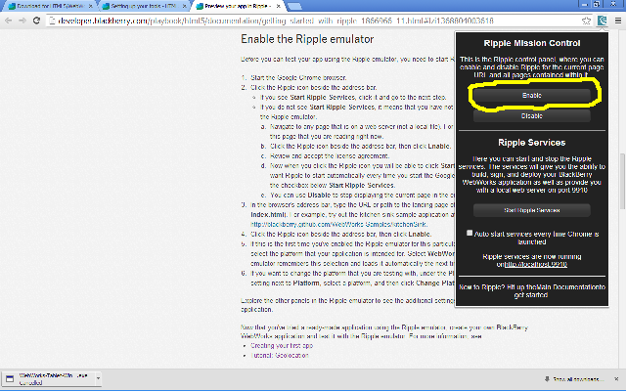
- If this is the first time Ripple is being used for a specific URL, it will ask what device it should emulate. Select WebWorks-TabletOS. If the URL has already been used, skip this step.
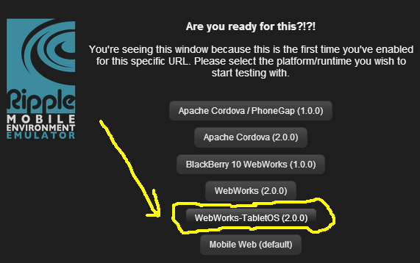
- The URL used should now appear inside a simulated playbook. There should be menus on both sides of the screen. Click on the Build Tab. Remember how to get to here, as it will be reference further in the report.
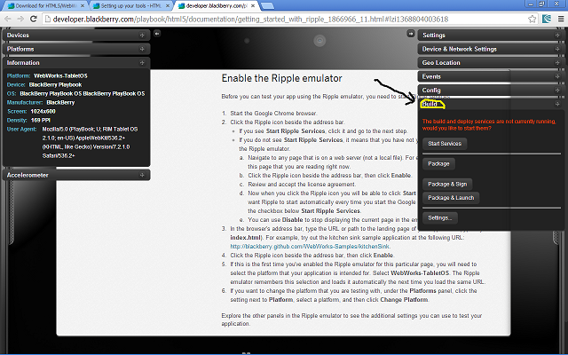
- Create a folder named “RippleSites” in “C:\Documents and Settings\User\RippleSites”.
Any app you want to use ripple with should be contained in its own folder inside the “RippleSites” folder.
- Go to URL https://www.blackberry.com/SignedKeys/codesigning.html and fill in the required fields. It is necessary for Blackberry to control which Apps can be put on the Playbook. To load one on, first a Signing Key must be requested from BlackBerry.
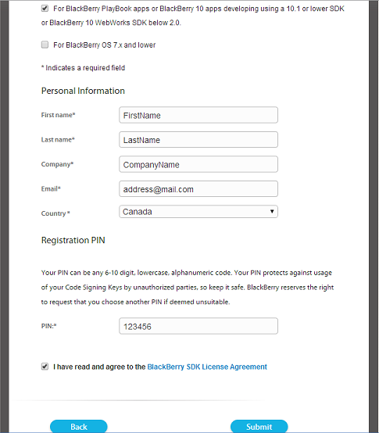
Note 1: Select the check box which says “For BlackBerry Plyabook apps…”
Note 2: The email put in the email field is the email the signing keys will be sent to.
Note 3: The PIN must be a 6 to 10 digit code with either numbers and/or lower digit letters.
Note 4: 123456 is a bad pin, it is only used as an example.
Note 5: Read and Agree to the BlackBerry SDK License Agreement
- BlackBerry may take minutes, hours, or days to respond to the request, depending on how busy they are. Once the email in received, save the 2 attachments in the “C:” drive. The 2 files should be similar to “client-PBDT-12345.csj” and client-RDK-12345.csj”. The numbers will not be 12345, but they will be the same for both files.
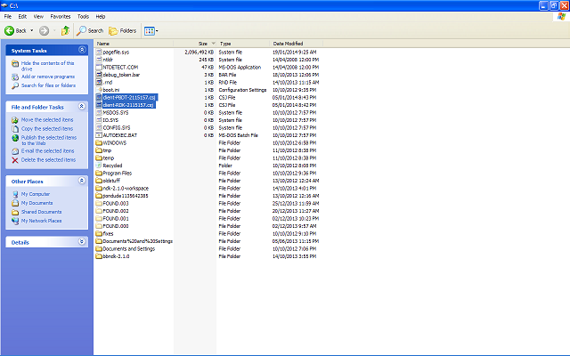
- Navigate to “C:\Program Files\Research in motion\BlackBerry WebWorks SDK for TabletOS 2.2.0.5\bbwp\blackberry-tablet-sdk\bin\” and search for the file called “blackberry-signer”. (Important: Do not use “blackberry-signer.bat” as it will not work). Keep this tab open.
- Navigate to the location the csj pins are stored. In this guide they are stored in the C: drive. Keep this tab open.
- Open the command prompt. Drag and drop the “blackberry-signer” file into the command prompt.
“C:\Program Files\Research in motion\BlackBerry WebWorks SDK for TabletOS 2.2.0.5\bbwp\blackberry-tablet-sdk\bin\blackberry-signer” should appear in the command prompt. Follow it with a space.
- Now type in the command “–register” followed by a space.
The password created when the keys were requested “-csjpin 123456” (123456 is replaced with the password), followed by a space.
The new password that will be used to sign apps, “-storepass rocket11” (rocket11 is replaced with a new password. Do not forget the new password.) followed by a space.
- Next drag and drop the “client-RDK-12345.csj” file from the C: drive into the command prompt. Then follow it with a space.
- Next drag and drop the “client-PBDT-12345.csj” file from the C: drive into the command prompt.
- Ensure that everything is correct. The command should look something like this, where underscores are spaces, and the text between <> is replaced with the respective values.
“C:\Program Files\Research in motion\BlackBerry WebWorks SDK for TabletOS 2.2.0.5\bbwp\blackberry-tablet-sdk\bin\blackberry-signer”_-regsiter_-csjpin_<password used when filling out the form>_-storepass_<password that will be used from now on>_client-RDK-<numbers>.csj_client-PBDT-<numbers>.csj
- Hit enter when everything is ready. The command prompt should indicate that the command ran successfully. If it indicates otherwise, check to make sure there were no errors in the command. If that still does not work try repeating steps 7-15 again to ensure that the files are valid.
- This command creates 3 files, which are located in “C\Documents and Settings\User\Local Settings\Application Data\Research In Motion\”. They authorize the signing of apps. Signing the apps makes the app capable of being put on a playbook.
Part C: Signing and Deploying
If part A and B are complete, for each subsequent app start at Part C, because the computer now has the authorization to sign and deploy apps to the playbook, and the tools are already installed.

- Ensure that the App has a “config.xml” file. This file configures the app to run in a certain way.
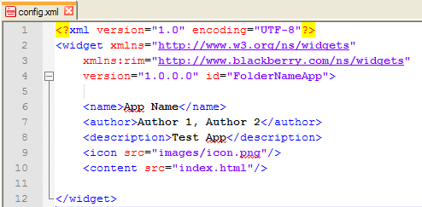
The above shows a minimalist example of the required fields.
-On line 4, id must equal the name of the folder that the app is in followed by “App” with no spaces.
-<name> Is the text the user will see under the App’s Icon on the PlayBook
-<author> List the Author’s of the App.
-<decription> A brief description of the app
-<icon> src is equal to the location of the images that will be used as an icon within the folder that everything is contained in.
-<content> src is equal to the location of the “index” file within the folder. An index file is the file that will be loaded upon touching the app’s icon. It is usually called “index.html”
- Ensure that all required files for the app, including the “config.xml” file, are in a single folder, and place this folder in “C:\Documents and Settings\User\RippleSites\”.
- Repeat part B steps 1-5 again so that there is a screen similar to image shown in step 5.
- There should be a message under the “Start Ripple Services” button saying that “Ripple Services are now running on http://localhost:9910” if a different number is there, used that number instead of 9910. What this means is that typing “http://localhost:9910” is the same as the “RippleSites” folder that was created in part B.
- After “http://localhost:9910” type in the location of the App’s index file, this should be “\FolderName\index.html”, with folder name being the name of the folder. Once “http://localhost:9910/FolderName/index.html” is in the address bar, hit enter, and there should be a preview of the app.
- Click on the build button, and then click on the settings button at the bottom of the tab that was opened (At the top there is another settings button, ignore this)
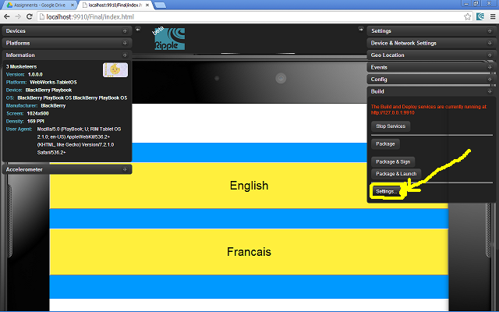
- Filled the required fields as follows:
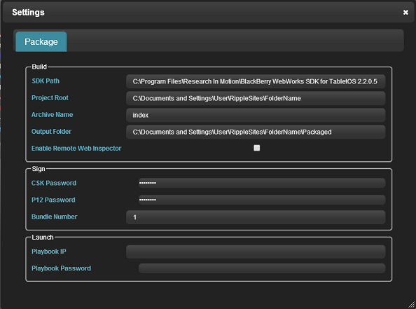
Replace FolderName with the name of the folder used. Replace User with the computer’s user.
When everything is complete click “x” to return. Note: Bundle Number refers to the version of the App being signed. If an App needs to be edited and signed again the bundle number must increment by 1. Note 2: The asterix are the keystore pass, which this guide defined as rocket11.
- Click package and sign in the build tab. It may or may not work on the first time. If it works a pop up will indicate “Build succeeded”, if not then try to click the button again. Sometimes clicking again without changing anything works. Otherwise there might be an error. Check the error message to get a clue of what it is. Most likely causes are the bundle number is a duplicate of the previous version signed, or that file names in the app are invalid. Make sure no special characters are in the file names. After making a fix attempt to sign again.
- If the build succeeds there will now be a folder inside the folder with the app called “Packaged” which contains a zip file containing the app, and an “index.bar” file. This is your app in a format the Playbook can read. Keep this tab open.
- Navigate to “C:\Program Files\Research in motion\BlackBerry WebWorks SDK for TabletOS 2.2.0.5\bbwp\blackberry-tablet-sdk\bin\” and find the “blackberry-deploy” file. Keep this tab open.
- Get the BlackBerry Playbook that the app will be loaded on.
- Turn it on. Touch the settings button in top left corner of the play book.
- Go to the Security Tab and click Development Mode.
- Slide Development mode from off to on.
- Input the devices password to authorize the change. Take note of the development address, it will be used later.
- Attach the computer to the playbook with the micro USB to USB Cable.
- Wait for a prompt to appear on the computer. Input the playbook password.
- Open the command prompt and drag and drop the “blackberry-deploy” file and then put a space.
Type command “-installApp” followed by a space.
Type “-password” followed by the space followed by the playbook password followed by another space.
Type “-device” followed by a space followed by the development address, followed by another space.
Type “-package” followed by a space.
Drag and drop the “index.bar” file into the command prompt.
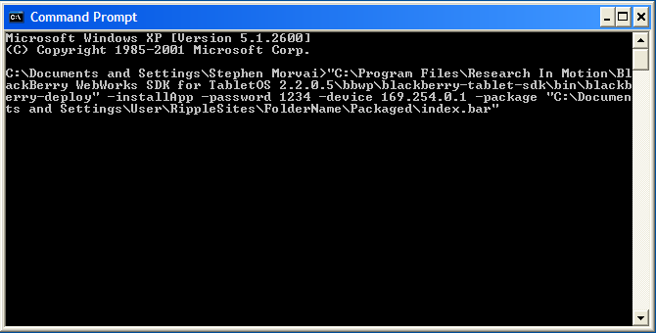

- Ensure everything is correct and hit enter. If the command prompt says “success” the app is on the playbook.
- Test the App.
21. If another app needs to be loaded onto the playbook, only part C needs to be repeated.

References:
BlackBerry WebWorks WebSite
http://developer.blackberry.com/playbook/html5/documentation/what_is_a_webworks_app_1845471_11.html
Download Google Chrome without a browser: Author Matt Silverman
http://www.mattsilverman.com/2013/02/download-google-chrome-without-a-web-browser-using-windows-command-line.html

FAQ
Q: “The Ripple Emulator won’t package my app. It keeps returning errors”
A: The Ripple Emulator is currently in Beta, so it is fairly buggy. Depending on the error message the issue might be nothing or something that actually is a problem. Sometimes trying again will fix the problem. See Trouble Shooting for more information.

Q: “Do I need to use the ripple emulator/I don’t have Chrome so I can’t use the Ripple Emulator”
A: The Ripple Emulator is just a User Interface for packaging the app and anything Ripple is capable of, can also be done from the command prompt.
Follow the instructions at this link to package with command prompt http://developer.blackberry.com/playbook/html5/documentation/compiling_packaging_your_ww_app_1866977_11.html

Q: “On the download webpage for the Ripple emulator and the Blackberry WebWorks SDK, the page also says I should download the Emulator, should I?”
A: It is up to you. The emulator allows you to visualize what the App will actually look like on a playbook, without having to go through the hassle of physically putting it on a playbook, but it is also unnecessary and so was left out of this guide.

Q: “If say I already downloaded all my tools, do I still required the internet to just package and sign my app and put it on a playbook?”
A: Yes you do. The whole point of the process of setting your computer up to be able to sign apps was so that when your computer sends a request, over the internet, blackberry already knows that your computer is a secure developer and signs off on the app allowing the app to work on the playbook.

Q: “The Command Prompt keeps returning errors”
A: 99% of the time this is caused by a format error. Check to see if everything is correct. The other 1% of the time this might be because the files are invalid. Ensure that the previous steps were followed correctly.

Trouble Shooting the Ripple Emulator
- The most common error you will see is not an error at all, and can be resolved simply by trying again
- If you’ve tried many times and it keeps returning the same error. Look closely at the error. If it mentions a specific file, then there is something wrong with that file. Most likely the file is named with a special character which makes it invalid.
- If you are trying to sign your app you need to include the keystore pass you defined when you used the csj files. In this guide it was called rocket11. Along with the passwords you need a bundle number. What the bundle number does is it differentiates between versions of the same program, so if you have already loaded a program of the same app, then the bundle number needs to be incremented by 1.
- Finally the Ripple emulator may not work because it does not like the fact that it is trying to package an app into a folder which has a packaged file already because it does not want to overwrite it. If this happens delete the old package to make way for the new.

